Setting up the Activity Log for a New Simulation

The first step is to rebuild the database to remove any data from previous simulation runs.
- Start the MySQL Control Center by clicking Start -> Programs -> MySQL Control Center -> MySQL Control Center.
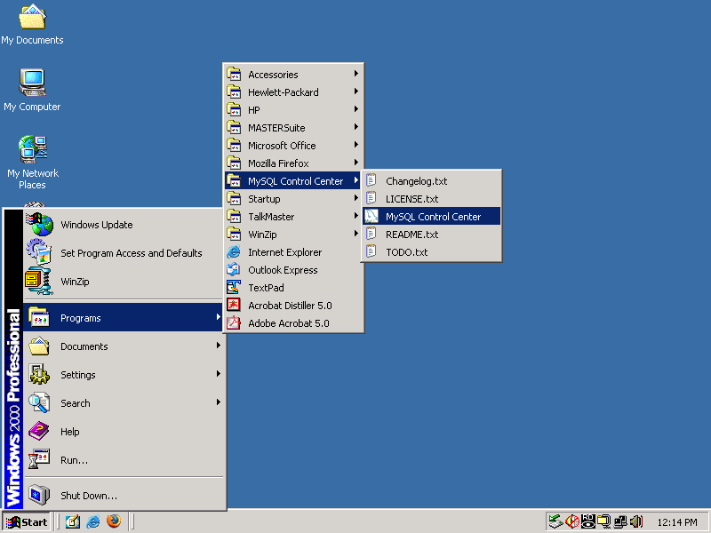
- Right-click the “activity_log” database, choose “Drop Database”, and confirm the drop.
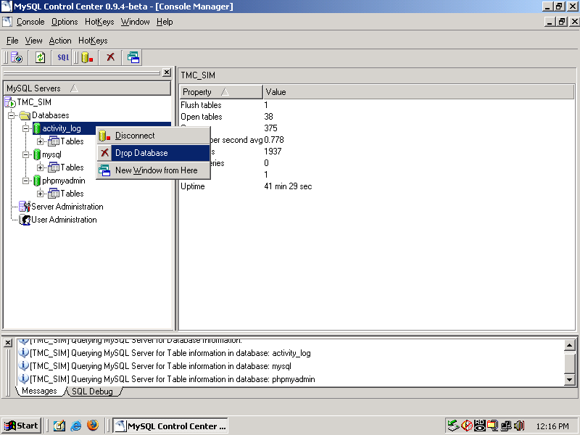
- Right-click the “Databases” folder, and choose “New Database”. Enter “activity_log” as the name for the new database, and click OK.
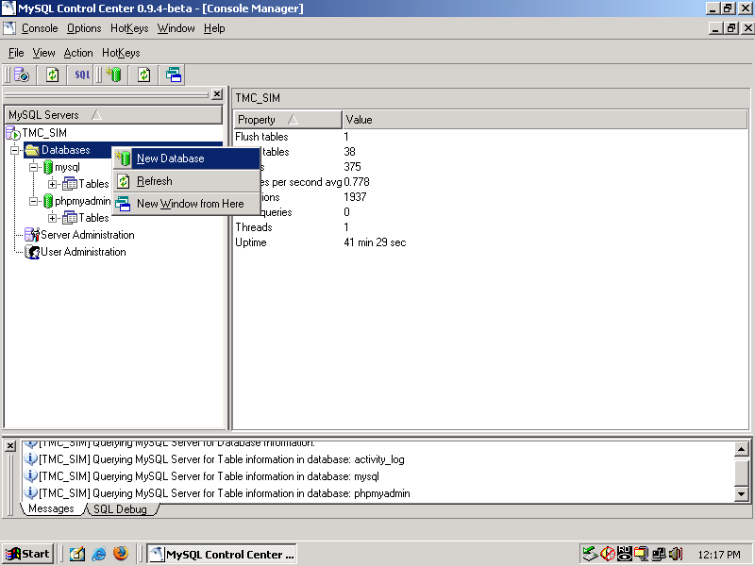
- Double-click the new “activity_log” database to connect to it. The cylinder icon next to it should change from gray to green.
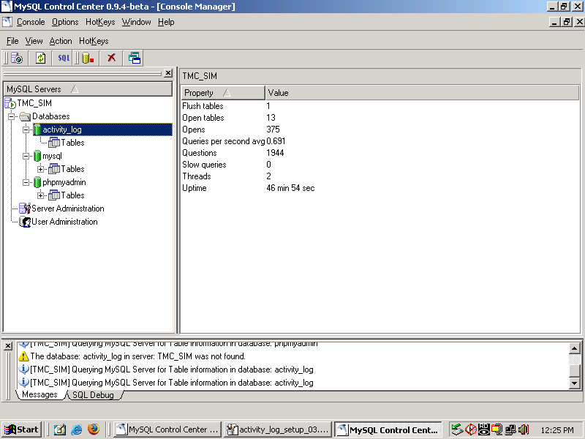
- Open the SQL Query window for this database by clicking the SQL button (3rd button from the left) in the toolbar. A query window will open.
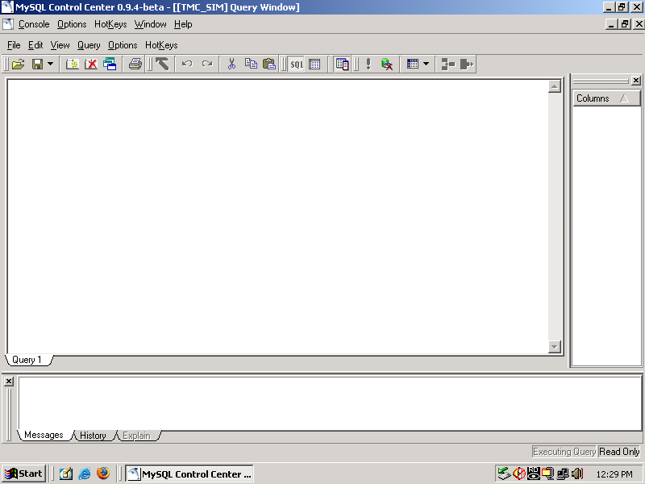

- Open a Windows Explorer window by holding down the Windows key, and press “E”. Navigate to the C:\www\webroot\data directory.
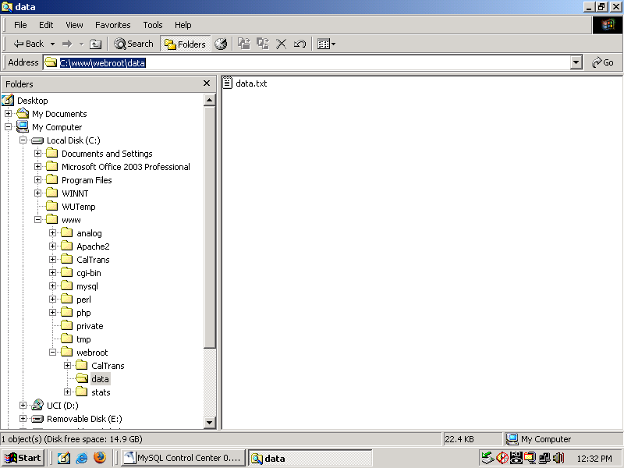
- Open the data.txt file in the directory by double-clicking it. Select the entire contents of the file by holding down the Ctrl key, and press “A”. Copy the file to the clipboard by holding down the Ctrl key, and press “C”.
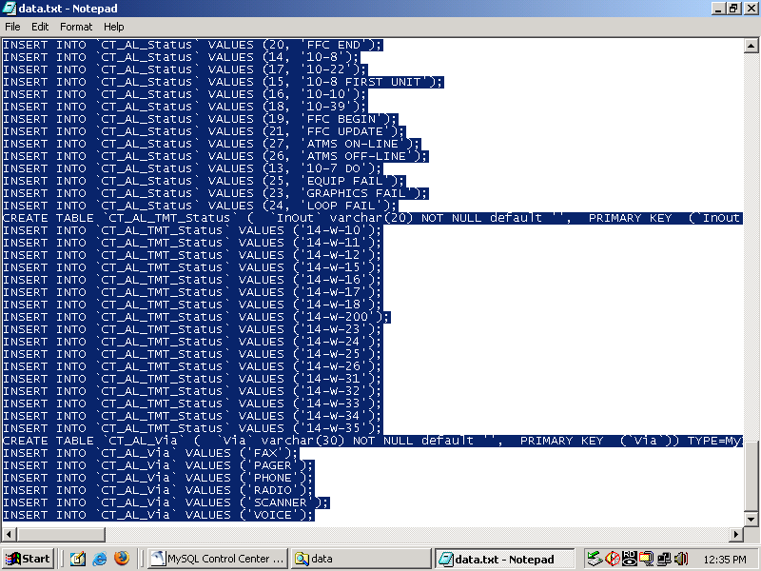
- Switch back to the MySQL Control Center, right-click in the main Query pane, and choose “Paste” to insert the copied data file. Execute the copied commands by clicking the exclamation point button (5th button from the right) on the toolbar.
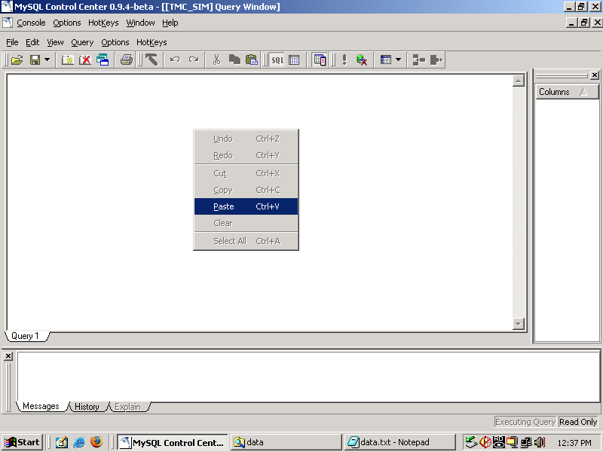
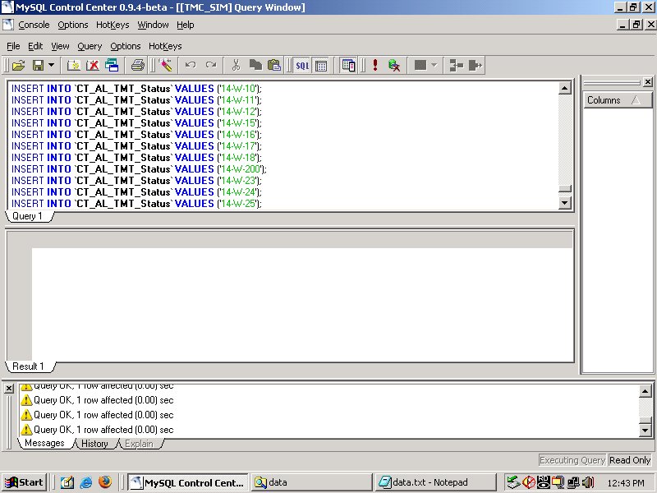
- Close the Query window by clicking the lower of the two “X” buttons in the upper-right of the window. Right-click on the “Tables” item of the “activity_log” database, and choose “Refresh”. Tables should have been created and populated as shown below.
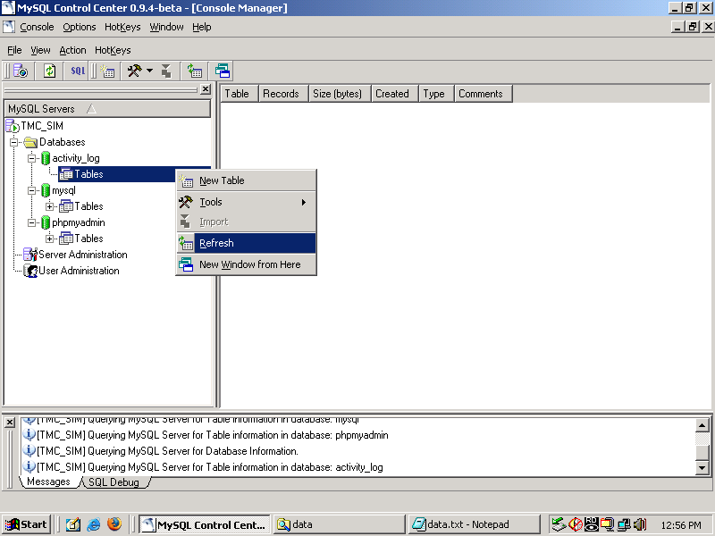
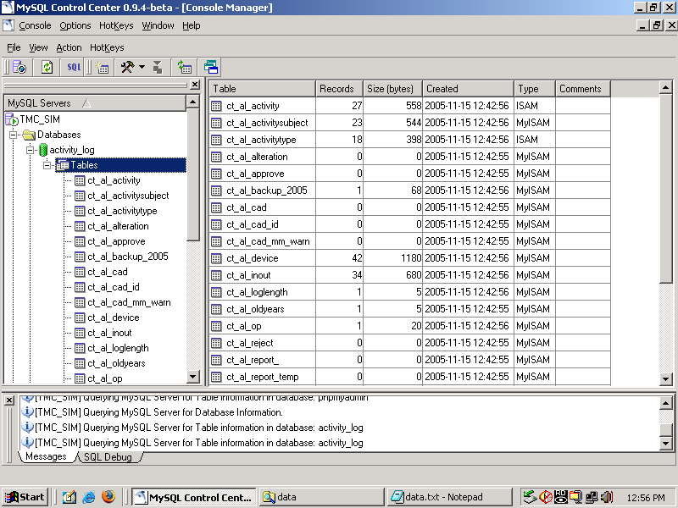
- Close the MySQL Control Center. Open Internet Explorer, and click the “Caltrans Activity Log Simulator” shortcut in the Links toolbar. Click the “District 14” link, and open choose “TMC Activity Log (Window)” to open the Activity Log. Login to the “Administrator Login” using the following username and password:
Username: activity_log
Password: admin

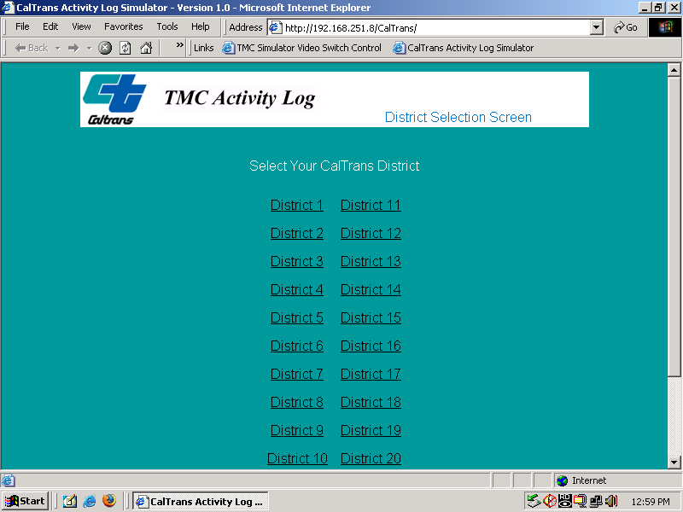

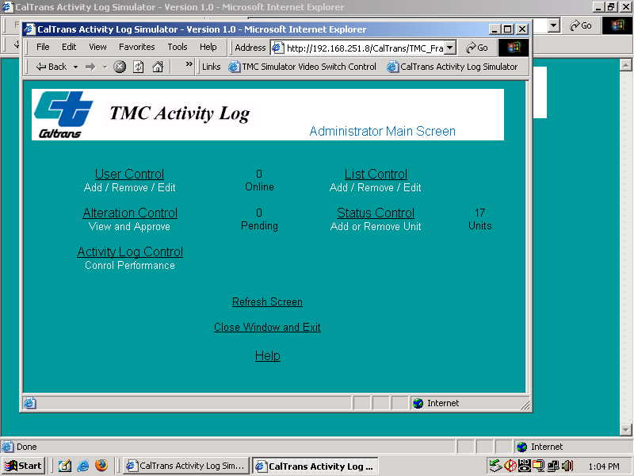
- Add users and change units as necessary per Activity Log instructions.

